

**Faculty of Engineering & Technology**

**Electrical & Computer Engineering Department**

**COMPUTER DESIGN LABORATORY ENCS 4110**

**Experiment No. 10: DC Motors and PWM**

**Report 3**

**Prepared by:**

Mohammad Abu Shams 1200549

**Instructor**: Dr. Abualseoud Hanani  
**Assistant**: Eng. Raha Zabadi

Section: 1

Date: 24-8-2022

Birzeit

# 

# **Abstract**

DC motors are devices that transform electrical energy into various types of energy (mechanical). They require a very high current, which necessitates the use of an external generator. In this experiment, we'll use pulse width modulation to regulate the speed of a DC motor (PWM). We cannot drive a DC motor from a digital pin since they require a high current (even if the motor runs on 5 volt). Consequently, we require a driving circuit. Motors can be driven by transistors. Using the H-Bridge technique, we'll also reverse the motor's rotational orientation once it has been operating. We will use Arduino to generate PWM signal that to drive the DC motor with different speeds.

**Table of Contents**

Abstract I

List of figures III

Theory 1

Components 2

**DC Motors** 2

**BJT Transistor** 3

**MOSFET Transistors** 4

**PWM** 5

**H-Bridge** 6

Procedure 7

Part1 7

Task1 10

Part2 11

Task2 14

Conclusion 16

Feedback 17

References 18

# **List of figures**

Figure 1: A small DC motor 2

Figure 2: Using BJT to drive a motor 3

Figure 3: Using MOSFET to drive a motor 4

Figure 4: PWM 5

Figure 5: H-Bridge 6

Figure 6: L298 Motor Driver Module 11

# 

# **Theory**

In this experiment, we will use these components:

1- Arduino

2- Breadboard

3- DC-Motor

4- Wires

5- BJT, NPN Transistor (2N2222)

6- Diode (1N4001)

7- Resistors (330 Ohm)

8- H-Bridge L298

## **Components**

### **DC Motors**

A DC motor is any of a class of rotary electrical motors that converts direct current (DC) electrical energy into mechanical energy. The most common types rely on the forces produced by magnetic fields. Nearly all types of DC motors have some internal mechanism, either electromechanical or electronic, to periodically change the direction of current in part of the motor.

DC motors were the first form of motor widely used, as they could be powered from existing direct-current lighting power distribution systems. A DC motor's speed can be controlled over a wide range, using either a variable supply voltage or by changing the strength of current in its field windings. Small DC motors are used in tools, toys, and appliances. The universal motor can operate on direct current but is a lightweight brushed motor used for portable power tools and appliances. Larger DC motors are currently used in propulsion of electric vehicles, elevator and hoists, and in drives for steel rolling mills. The advent of power electronics has made replacement of DC motors with AC motors possible in many applications [1].

Even small DC motors draw relatively high current. The toy dc motor shown below draws 70 mA and runs on 5volt DC.

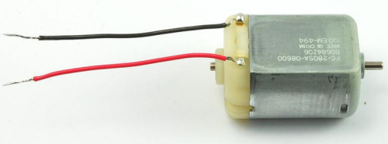

Figure 1: A small DC motor

### **BJT Transistor**

A bipolar junction transistor is a three-terminal semiconductor device that consists of two p-n junctions which are able to amplify or magnify a signal. It is a current controlled device. The three terminals of the BJT are the base, the collector, and the emitter. A signal of a small amplitude applied to the base is available in the amplified form at the collector of the transistor. This is the amplification provided by the BJT. Note that it does require an external source of DC power supply to carry out the amplification process[2].

We need a driving circuit to run the motor. We can use a BJT transistor as a driver for the DC motor. We need a resistor on the base to limit the current from the digital pin. The diode is needed to protect the transistor.

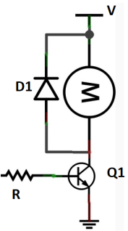

Figure 2: Using BJT to drive a motor

### **MOSFET Transistors**

The MOSFET (Metal Oxide Semiconductor Field Effect Transistor) transistor is a semiconductor device that is widely used for switching purposes and for the amplification of electronic signals in electronic devices.  A MOSFET is either a core or integrated circuit where it is designed and fabricated in a single chip because the device is available in very small sizes.  The introduction of the MOSFET device has brought a change in the domain of switching in electronics. Let us go with a detailed explanation of this concept [3].

Because motors usually draw large current, MOSFET transistors are usually used to drive DC Motors.

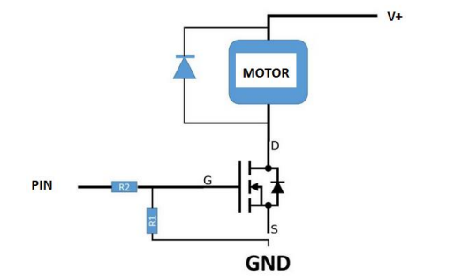

Figure 3: Using MOSFET to drive a motor

### **PWM**

Pulse Width Modulation (PWM) is a fancy term for describing a type of digital signal. Pulse width modulation is used in a variety of applications including sophisticated control circuitry. A common way we use them here at SparkFun is to control dimming of RGB LEDs or to control the direction of a servo. We can accomplish a range of results in both applications because pulse width modulation allows us to vary how much time the signal is high in an analog fashion. While the signal can only be high (usually 5V) or low (ground) at any time, we can change the proportion of time the signal is high compared to when it is low over a consistent time interval [4].

We can pulse output on and off fast such that the connected device sees the result as a lower voltage. This way, we can control the speed of a DC-motor.

We define: duty cycle= (ON period)/(ON+OFF periods)

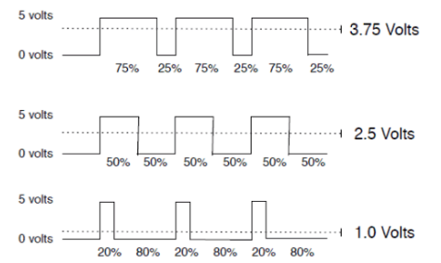

Figure 4: PWM

So, for a duty cycle of 50% and source voltage =12 volt, the load will see 6 volts.

In Arduino we can use **analogWrite(pin, value)** to generate a PWM signal with duty cycle value/255 where 0≤value≤ 255

### **H-Bridge**

An H-Bridge is a circuit of 4 switches allowing to select the direction of current flowing through a part. The simplest H-Bridge consists of four manually controlled switches. The name is derived from the circuit diagram which looks like a capital H.

When using an H-Bridge it is important to prevent switches to short circuit the supply voltage. In a few H-bridge designs additional circuitry prevents accidental short circuits, but most available chips don't have this protection [5].

To change the rotation direction of a DC-motor we need to reverse the polarity. This can be done using H-Bridge as shown in Figure 4. If Q1 and Q4 are ON while Q2 and Q3 are OFF, the motor can run clockwise, now of Q2 and Q3 are ON, while Q1 and Q4 are OFF, the motor is going to reverse the direction.

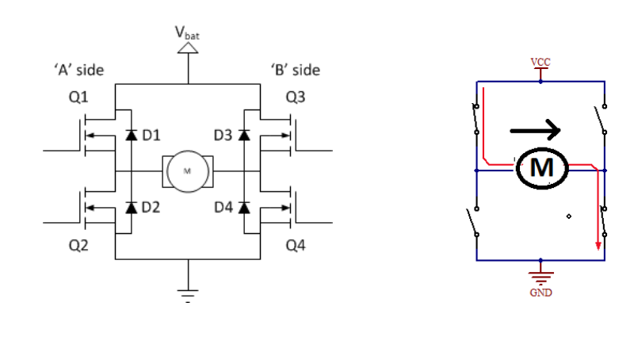

Figure 5: H-Bridge

# **Procedure**

## **Part1**

Use a transistor the control the speed of a DC-Motor.

I connected the circuit as shown in figure 2. Connected pin number 9 to the base on the Ardunio. Here is the circuit which I built in **Thinkcard.com.**

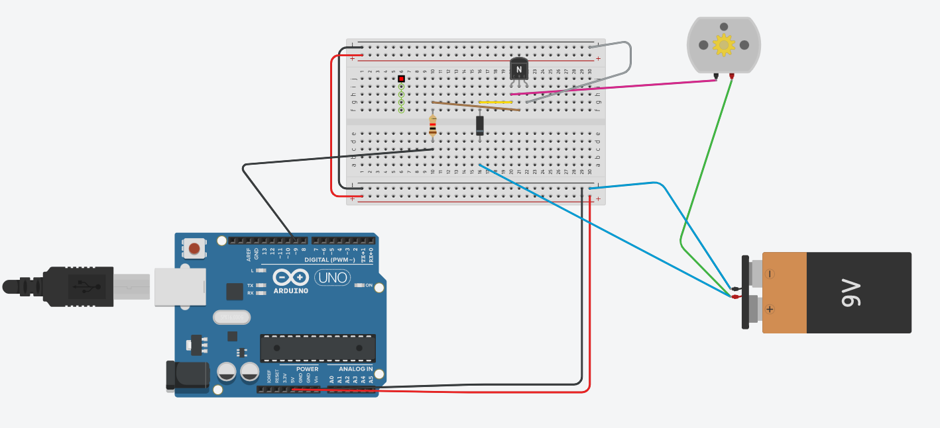

The code:

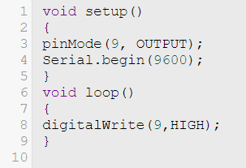

First I used

**pinMode(9,OUTPUT);**

**digitalWrite(9,HIGH);**

Because the output pin 9 of the digitalWrite() function has a high value and it is connected to the transistor driving the DC motor, the output of running this code is that the DC motor has rotated and it’s speed equal 17473 rpm.

Then I used **digitalWrite(9,LOW);**

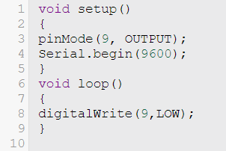

The output pin 9 of the digitalWrite() function has a low value and it is connected to the transistor driving the DC motor, the output of running this code is that the DC motor has not rotated and it’s speed equal zero.

After that I used **analogWrite (9,200);**

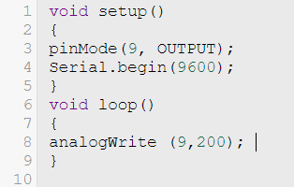

The result is that the motor starts rotating in an analog speed, the number of rotations per minutes was changing all time

Duty cycle= (200/265) *100%

= 78.125%

Finally I used **analogWrite(9,64);**

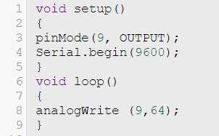

Duty cycle in this case = (64/265) *100%

= 25%

The difference between two last cases is that the analog speed in last case is less than previous case.

**Task1**

Using Serial monitor, write a code to read a number from keyboard and change the speed of the motor. You have to check if the number between 0 and 255. Print an error message if the number outside this range. Show the result to the instructor.

**The code :**

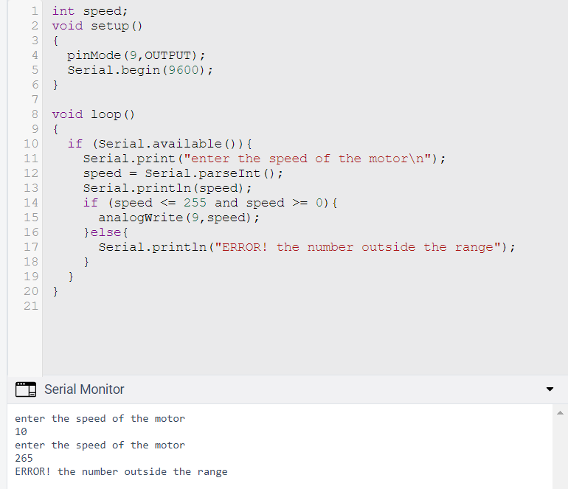

## **Part2**

I used H-Bridge to control the speed and direction of a DC-Motor, I used L298 Motor Driver Module to control the speed and direction of a DC-Motor.

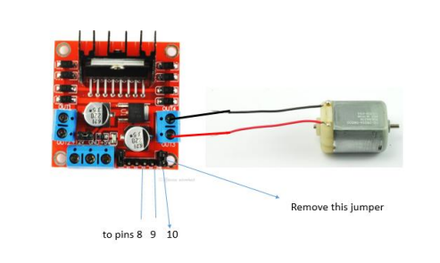

Figure 6: L298 Motor Driver Module

I connected the circuit as in Figure above.

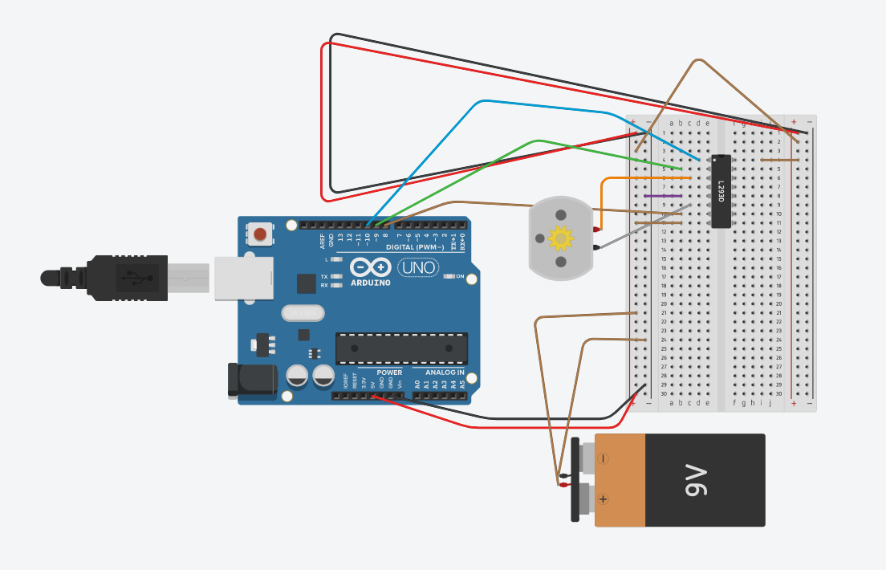

Write a code such that pin#8 is 1, pin#9 is 0 and generate a PWM signal at pin#10 with duty cycle 100%.

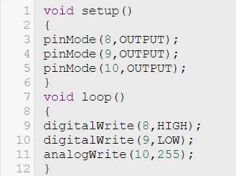

The dc motor rotates in a counterclockwise direction with a positive magnitude but a negative speed.

Then I changed pin#8 to 0, pin#9 is 1.

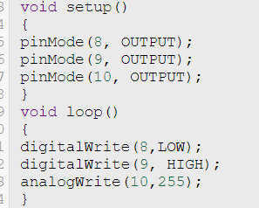

The dc motor rotates in a clockwise direction with a positive speed. The only difference is that the rotation has changed.

After that I changed the duty cycle at pin#10 to 50%

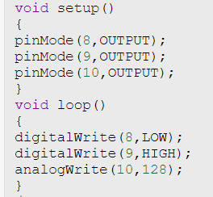

The analog speed of the DC Motor is clockwise rotation. When the duty cycle is 50%, the motor moves at a slower speed than when it is 100%.

## **Task2**

Write code such that you can control the direction and speed of a DC-Motor from the keyboard. Show the result to the instructor.

The code:

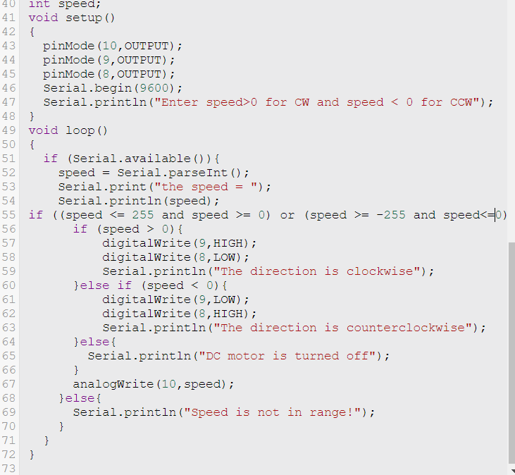

Running the code:

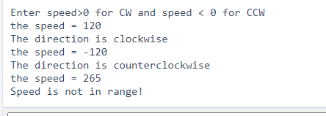

The direction of the DC motor can be controlled only by switching the high & low values of the switches that are connected to 8 & 9 pins of the H-Bridge together: make the high value low, and the low value high. That will reverse the direction of the rotation.

However, the user has the option to alter the motor's speed by entering a value between 0 and 255. Print an error message if another value outside of that range was added.

# **Conclusion**

In this experiment, I learnt about DC Motors and PWM. I learnt how to control the speed of a DC motor using transistors. I learnt how to control the direction of a motor using H-Bridge method. I built some circuits and I wrote some codes on this topics. DC Motors require more current than what the Arduino board provides, they cannot be linked directly to the Arduino, so we use a device circuit to connect them. Now I can deal with DC Motors.

# **Feedback**

This experiment is a nice one, I learnt some new ideas about DC Motors and PWM and the time of this experiment was perfect and I finished my tasks before ending time.

# **References**

*[1] DC Motor*. (2022, 8 24). Retrieved from Wikipedia: https://en.wikipedia.org/wiki/DC_motor

*[2] Bipolar Junction Transistor (BJT)*. (2022, 8 24). Retrieved from BYJU'S: https://byjus.com/physics/bipolar-junction-transistor/

*[3] The MOSFET (Metal Oxide Semiconductor Field Effect Transistor)*. (2022, 8 24). Retrieved from elprocus: https://www.elprocus.com/mosfet-as-a-switch-circuit-diagram-free-circuits/

*[4] Pulse Width Modulation (PWM)*. (2022, 8 24). Retrieved from sparkfun: https://learn.sparkfun.com/tutorials/pulse-width-modulation/all

*[5] H-Bridge*. (2022, 8 24). Retrieved from Bauhaus-Universitat Weimar: https://www.uni-weimar.de/kunst-und-gestaltung/wiki/H-Bridge